Hey Eric,
Here are the updated billboard designs with the Static and Digital versions. Let me know if there's any feedback on the designs or on the way the files are built.

Dropbox Link - https://www.dropbox.com/sh/495pns9bbxbzj8h/AABqIf4tKRKtpYOoXFclUWjXa?dl=0

Cheers!
Maria Grieshaber
Brand Director
Cigar City Brewing
www.cigarcitybrewing.com

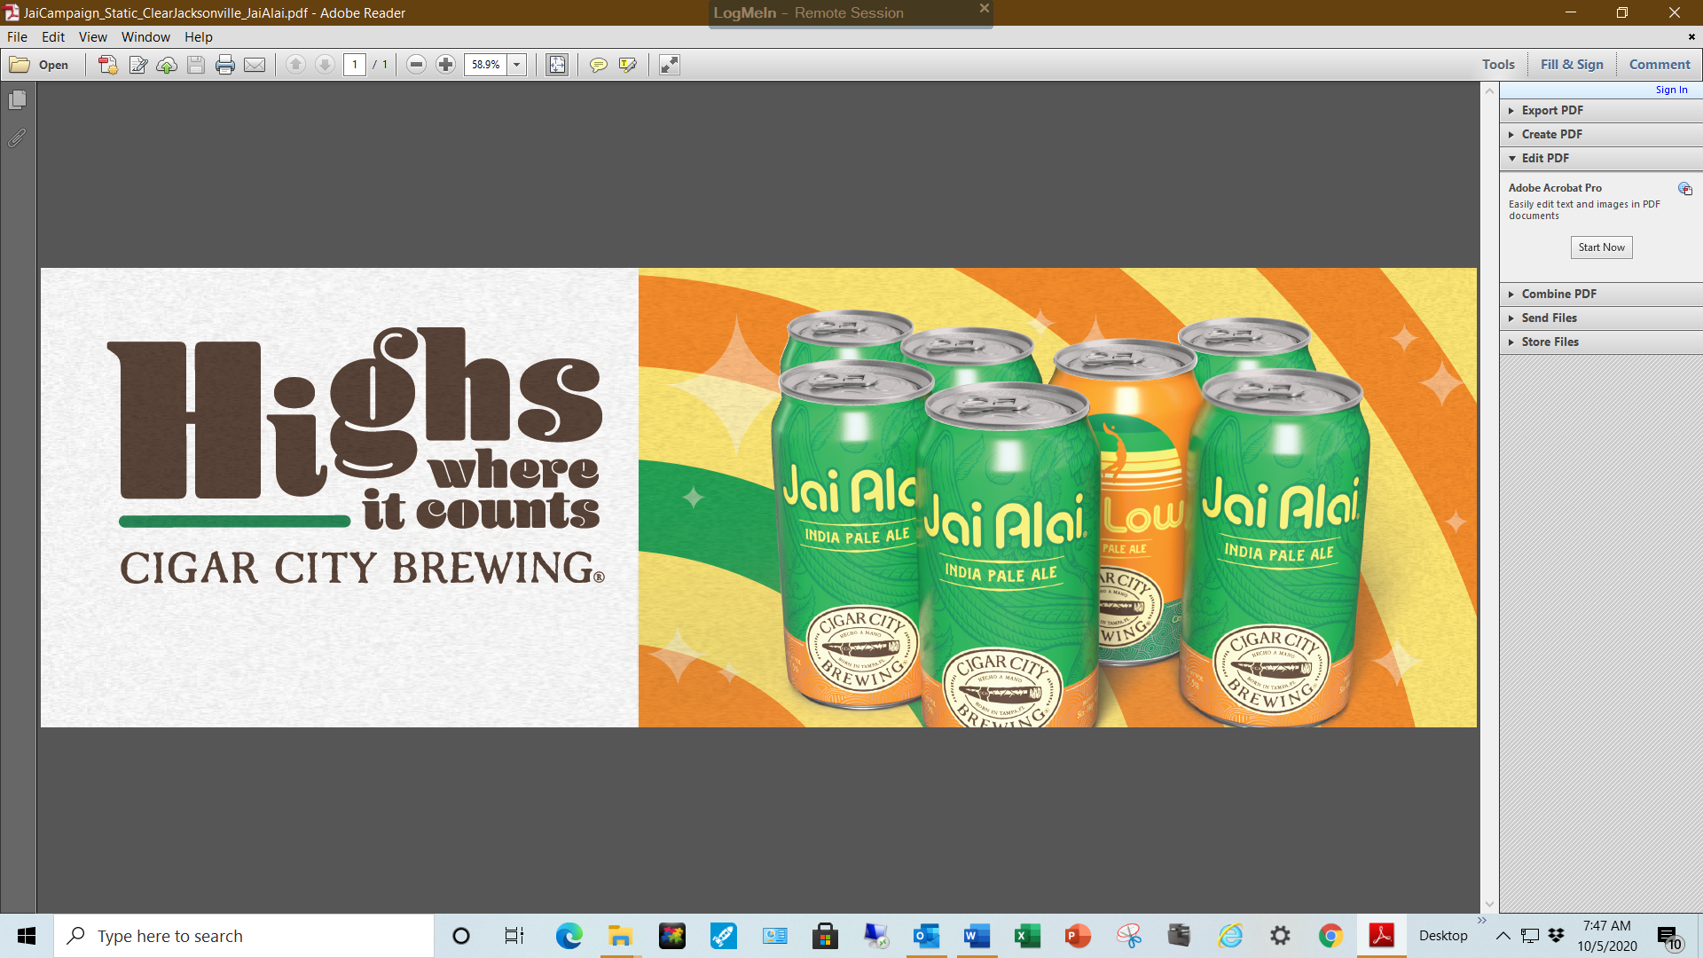
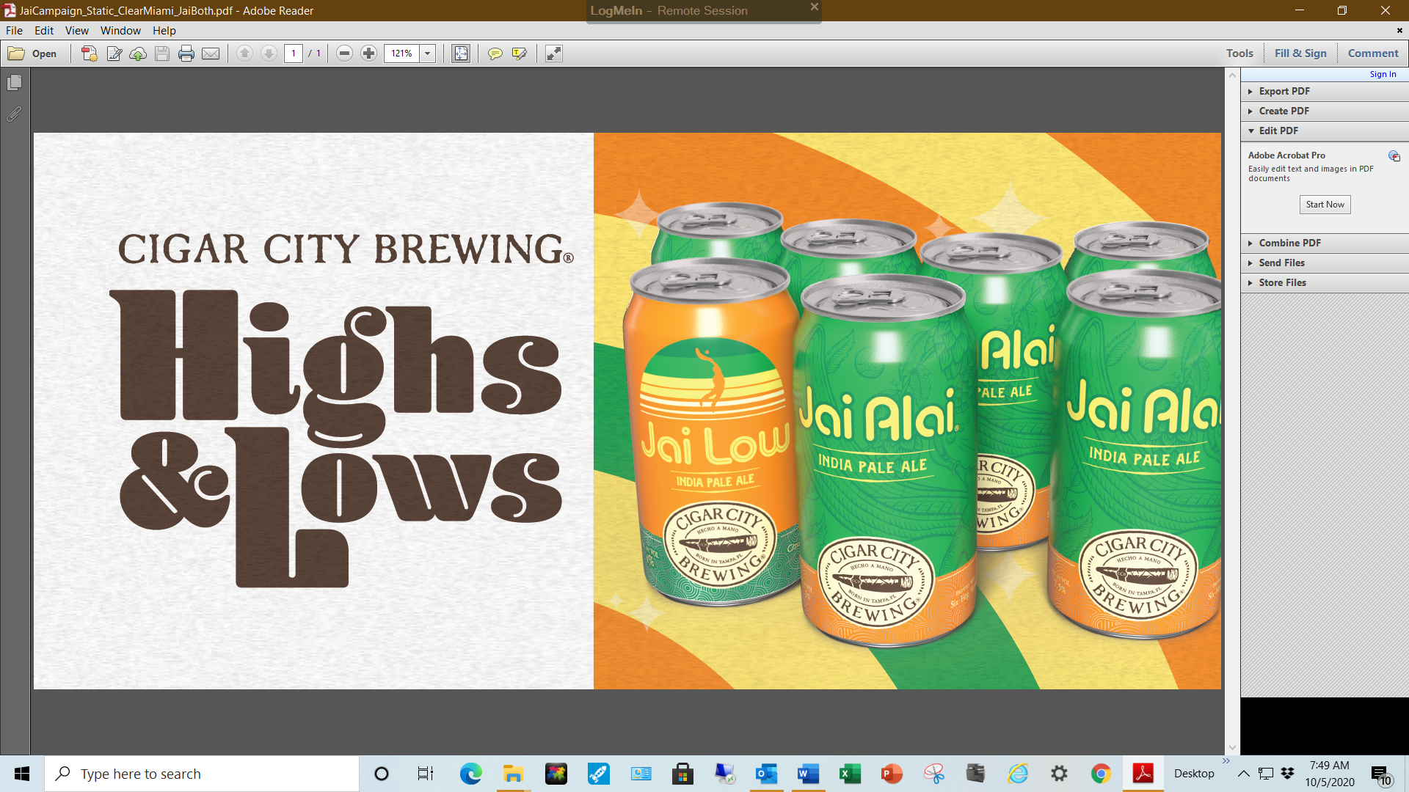
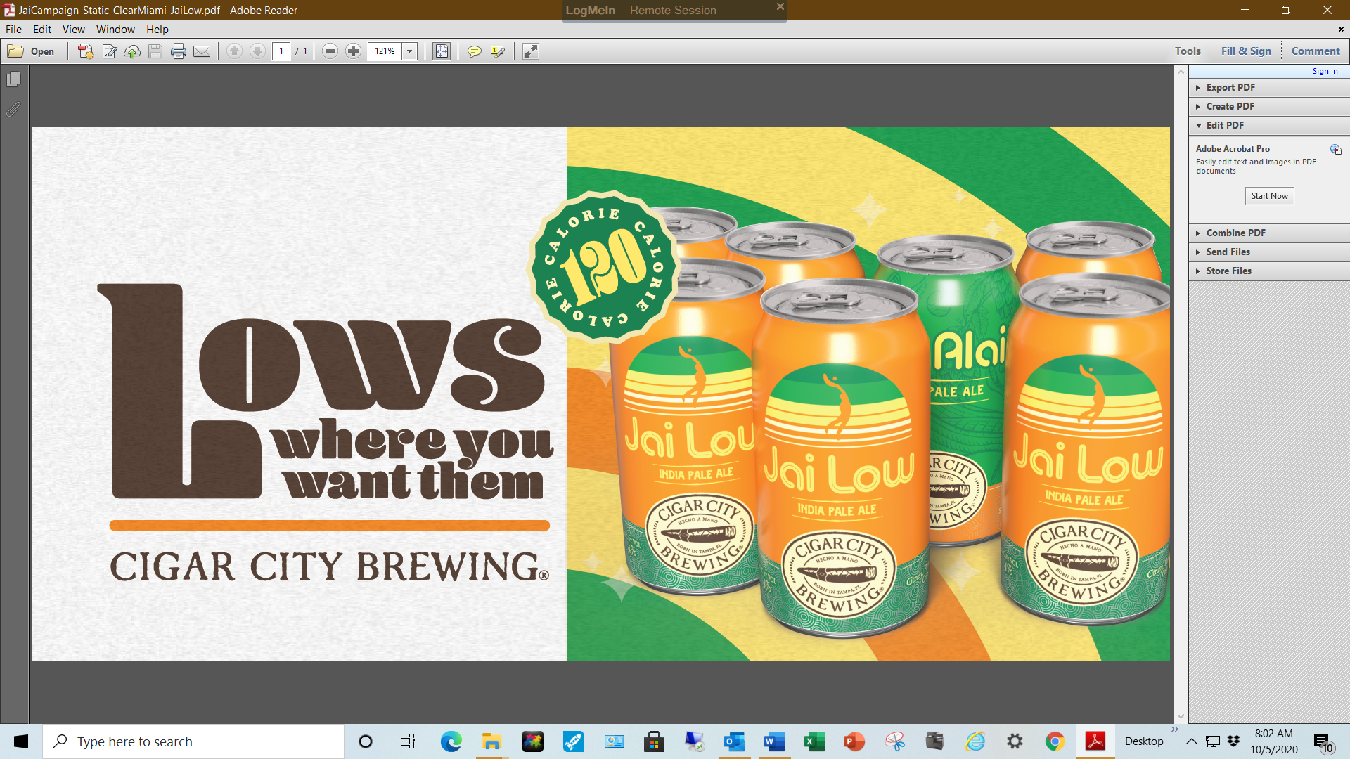

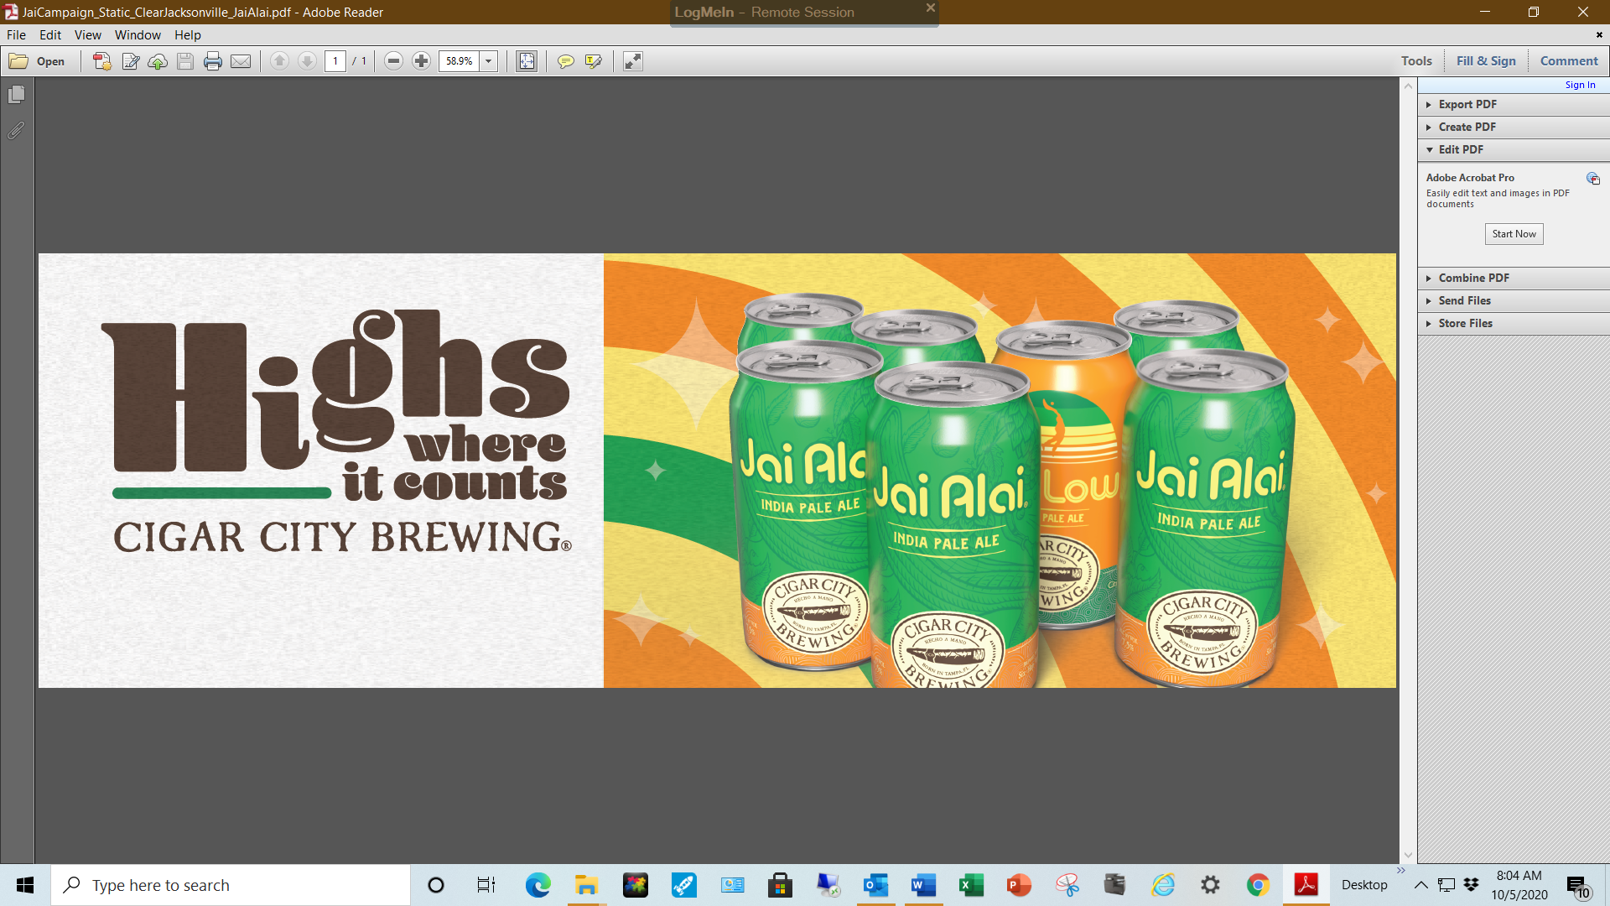
Bulletin
